

**SPORTS MANAGEMENT**

**Project plan**

**PRT 455 Software Engineering Practice**

HELEN JOSE CHITTOOPARAMBIL

(S288262)

Muhammad Ali Malik

(S289875)

Imran

Table of Contents

1.1 Background 2

1.2 Aim 2

1.3 Scope 3

1.4 Objective 3

2. Product Description 3

3. Requirements 5

4. Design 6

5. Test Plan 7

6. Release Plan 7

7. Completed and Remaining Tasks 7

1. **Introduction**

## 1.1 Background

Arranging the sports and events can be tiresome and difficult process sometimes. The people are organizing the sports events through meetings and publishing them on different social Media. But these procedures are sometimes time and money consuming. To make the sports management and organization’s easy, we come up with a web application named sports management. The sport management is focused to allow the people to register different sports events, deciding venue and time for the sports and challenge others. Our application is not only focused on the individual persons but also the team can also join into it through registration and can perform the functionalities that a single person can. This also allow the people to book or buy the ticket for the sport events. The users can view the sport event page so that they can see which events are upcoming.

## 1.2 Aim

The aim of this project is to make a web based application called sports management. This application allows all the people to register into it and helping them to create sport events and selecting the venue and time. They also can challenge others for their sport event. The application not only focused on individual sport item but also focuses on the group. To make all this easier, the application allows the user to chat with each other and people can buy ticket through sports management.

## 1.3 Scope

The scope of this application is to help the user to identify the nearby sport events that they like and help the people to manage and organize the sport events without any meeting or publishing it into different places. By organizing the sports through this application, helps to reach maximum of audience. This application will provide the information so that the users can identify the events which are coming soon.

## 1.4 Objective

Develop a web application that satisfy the criteria and requirements by meeting the quality and timeline which are already planned.

## Product Description

* 1. **Product Perspective**

Sports Management system is supposed to be an open source. It is a web based system using client server model. Product perspective contains major product features, system interface, design and implementation constraints, dependencies and development process.

* 1. **System Interfaces**

System Interfaces includes user, hardware and software interfaces of the product.

* + 1. **User Interface**

The User Interface of sports management system shall be compatible to any internet browser such as Internet Explorer, Google Chrome, Firefox, Mozilla or Netscape through which user can access to the system.

* + 1. **Software Interface**

The user’s browser should be HTML5 compatible for a acceptable user experience.

* + 1. **Hardware Interface**

Since the sports management system must run over the internet, so hardware device should be enable with internet.

* 1. **Major Product Functions**
* User Account
* Cross platform support
* Sport Event Management
* Sport Challenge Management

Sport Team

Individual User

* 1. **Design and Implementation Constraints**

The system is provisioned to be built on the ASP .NET MVC framework which implements the model-view-controller pattern. SQL Database will be used for data exchange and data storage. SQL Database Management Studio will be used for data management in initial stages of development.

* 1. **Dependencies**

This application highly depends on type and version of browser being installed on the system.

* 1. **Development Process**

For the development of this application waterfall development methodology is being followed and version control management Github is used.

* 1. **User Characteristics**

User of Sports Management System must be familiar with internet or have basic knowledge of operating the internet and have access to it.

## Requirements

* 1. **Functional Requirements**
* The application should be web based
* User receive correct information about the sport events from the application.
* User will be able to understand the GUI easily.
* System functionality is improved for better performance.

|  |  |
| --- | --- |
| Requirement | Description |
| New user Registration and Login | User signup, sign in with new user credential, password forgot and reset options. |
| Post events | Post the new events with date and venue. |
| Challenge Participants | Challenge other users for the sport events. |
| Chat with others | Chat for allowing the users to communicate with each other’s to manage the sports. |
| Mange Group event | The people can also arrange group events by organising group within the users of the application. |
| Manage the application | Administrator will maintain the software quality |

* 1. **Non-Functional Requirements**
* Better response time between interfaces
* Required temporary memory to run the application
* Safety and security about the user information
* Speed and reliability of the application

## Design

* 1. **Architectural Design**

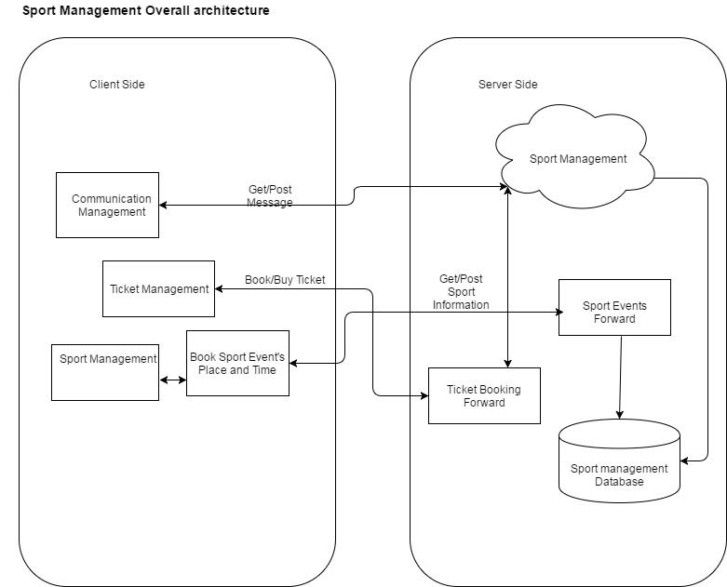

* 1. **Design Viewpoint 1: <Name of Viewpoint>**
  2. **Design Viewpoint 2: <Name of Viewpoint>**

Choose 2 design viewpoints from **Table 1** that are most appropriate for your product, and describe your product from the selected viewpoints by providing appropriate UML diagrams.

## Test Plan

System testing of sports management system will include user interface testing, use case testing and system unit testing. All features of application will be tested using suitable testing techniques and tools. For user interface testing black box testing technique will be used, all scenarios for this testing will be given in detailed document of Test Plan. For each use case there will at least two cases will be written one for pass scenario and one for fail scenario. Development IDE (visual studio) and internet browser will be used for use case testing. For unit testing test driven development (TDD) methodology will followed, for each system unit test code will be written before its actual implementation and visual studio IDE unit testing tool will be used for unit testing of system. Integration testing will also be used as we are developing our application into parts.



## Release Plan

## Completed and Remaining Tasks

List (or tabulate) all of the modules (or work packages, or tasks) of your project. For the modules you have completed, record the time you spent on each one. For the modules that still remain, record the estimated time to complete each one. Clearly mark the completed modules.

**Resources Used in Preparation of This Report Template**

1. IEEE Std 830-1998, IEEE Recommended Practice for Software Requirements Specifications.
2. ISO/IEC/IEEE 29148, Systems and Software Engineering - Life Cycle Processes – Requirements Engineering.
3. IEEE Std 1016™-2009, IEEE Standard for Information Technology - Systems Design – Software Design Descriptions.
4. IEEE Std 829™-2008, IEEE Standard for Software and System Test Documentation.